**MY RESUME**

**Md. Morshedul Alam Murad**

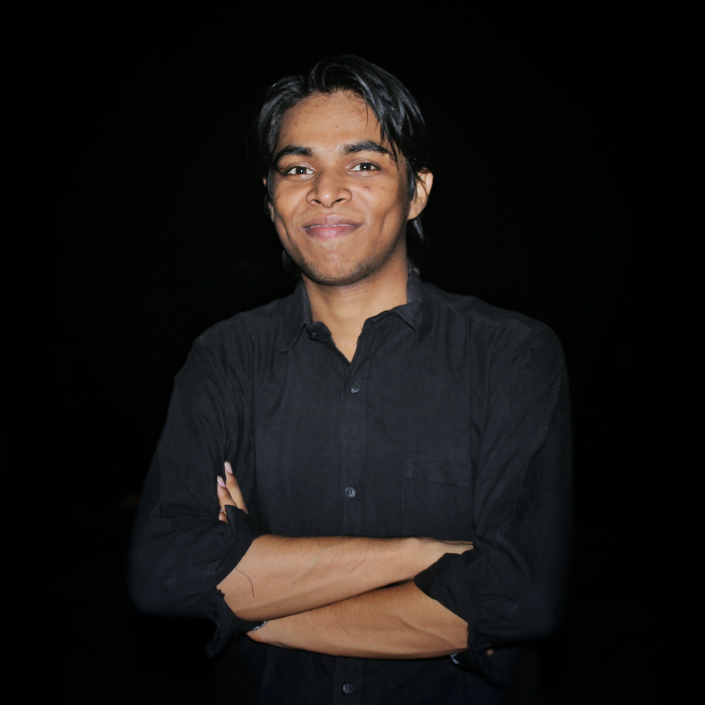

**Bashundhara, C-block, Dhaka**

**mamwithbrothers@gmail.com**

**Contact no: +8801627175866**

**CAREER OBJECTIVE**

**I have a vision to see myself in a highly efficient administrative position of a dynamic organization where I can utilize my learning, interpersonal skill, analytical ability and adaptability for further development.**

**CAREER SUMMARY**

**Looking for hard and challenging job where I will have the scope to prove my potentiality and skill to do something innovative and where I will be able to enhance my knowledge.**

**ACADMIC QUALIFICATION**

|  |  |  |  |  |  |
| --- | --- | --- | --- | --- | --- |
| **Qualification** | **Board** | **School/Collage** | **Year of passing** | **Grade** | **Gde** |
| **S.S.C** | **Chittagong** | **Govt. Muslim High School** | **2009** | **5.00** | **GPA-3.80** |
| **H.S.C** | **Chittagong** | **Govt. City College** | **2012** | **4.10** | **GPA-4.75** |
| **B.Sc in Computer Science & Engineering** | **Dhaka** | **Independent university Bangladesh** | **2015** | **3.00** | **Last two semester** |

**STRENGH**

* Good Communication and inter-personal skill
* Confident with positive attitude
* Self Motivated

**Knowladge In Programing Languages**

1. C+
2. Java
3. Python
4. PHP
5. Android App Development
6. Project base work like as Robotics

**Personal Details**

* Name : Md. Morshedul Alam Murad
* Married Status : No
* Hobbies:
  1. Singing Song
  2. Hardworking
  3. Gossiping
  4. Gardening